Slicer

* There are multiple visual available in slicer chart.
* Based on categories the chart will appear to visual.

First we have to create one Stacked column chart for use slicer.

**CT- Stacked column chart**

**Insights:**

* Here we are creating the visuals for sum of profit by year and month.
* In this visual we can analyze Month wise and year wise profit.
* July 2014 have got more profit (0.39M)
* September 2014 is the lowest profit(1.04M) month.

**Steps to reproduce:**

1. Select Stacked column chart from build visuals.
2. Pass date to X-axis

There are 4 types of date is available.

1. Year
2. Quarter
3. Month
4. Day

When we drop date to any action above mentioned types will display. In that list what type of data required for visual that type data only we have to take.

For this visual we have taken only year and month.

1. Pass profit to Y-axis
2. Pass year to legend

For pass year to legend means we can Drill down the visual for year to month.

1. Go to format your visual and turn on data labels.

Now we have to create slicer one by one

1. Vertical list

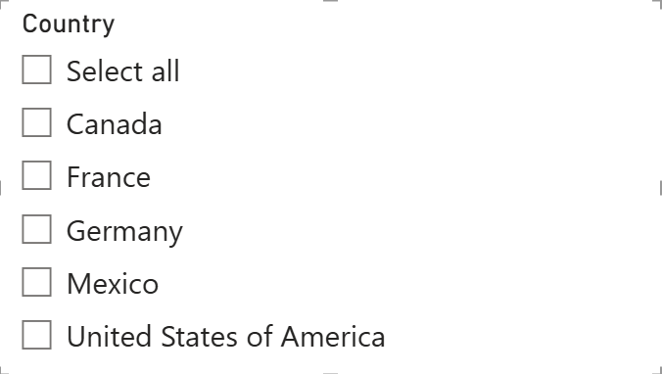

**Insights:**

* In this slicer we can select every country individually.
* Or we can select required country and
* Select all country’s at a time.

**Steps to reproduce:**

1. Select slicer from build visuals.
2. Pass Country to Field.
3. Go to format your visual and turn on Slicer header.
4. Slicer settings

Click on style

Options available

* Vertical list
* Tile
* Dropdown

Click on vertical list

1. Selection

Options available

* Single select
* Multi-select with CTRL
* Show “select all” option

Turn on Show “select all” option and turn off multi select with CTRL

If Multi select with CTRL is on cant able select multiple option in slicer.

1. Tile slicer

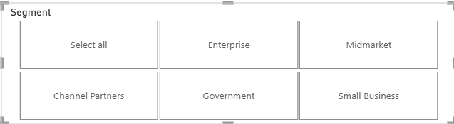

**Insights:**

* In this slicer we can select every Segment individually.
* Or we can select required Segment and
* Select all Segments at a time.

**Steps to reproduce:**

1. Select slicer from build visuals.
2. Pass Segment to field.
3. Go to format your visual and turn on Slicer header.
4. Slicer settings

Click on style

Options available

* Vertical list
* Tile
* Dropdown

Click on Tile

1. Selection

Options available

* Single select
* Multi-select with CTRL
* Show “select all” option

Turn on Show “select all” option and turn off multi select with CTRL

If Multi select with CTRL is on cant able select multiple option in slicer.

1. Dropdown Slicer

**Insights:**

* In this slicer we can select only one option.
* We cant able to select two options at a time.
* One by one we can select.

**Steps to reproduce:**

1. Select slicer from build visuals.
2. Pass Segment to field.
3. Go to format your visual and turn on Slicer header.
4. Slicer settings

Click on style

Options available

* Vertical list
* Tile
* Dropdown

Click on Dropdown

1. Selection

Turn on single select

1. Between

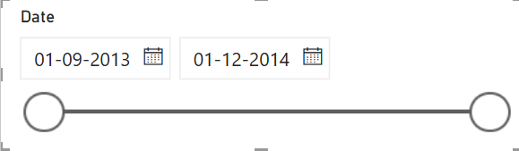 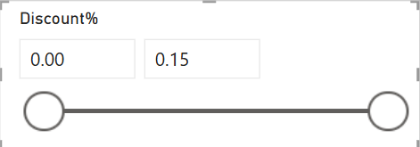

**Insights:**

* In this slicer we can get range between two value or two certain time.
* We can use only values or date for between slicer.

**Steps to reproduce:**

1. Select slicer from build visuals.
2. Pass Date or Discount% or any values (Sales,Profit,Unit sold)
3. Go to format your visual and turn on Slicer header.
4. Slicer settings

Click on style

Options available

* Vertical list
* Tile
* Dropdown

Based on data additional Options will add.

1. For Date value

* Between
* Before
* After
* Relative date
* Relative time

1. For Values

* Between
* Less than or equal to
* Greater than or equal to